Rcode.R

97252

2024-07-02

####################################   
### Step 1: read and tidy the data from mindware and GPS  
####################################   
  
## Moving average  
ma <- function(x,n=1500){  
 stats::filter(x,rep(1/n,n), sides=2)  
}  
## Read and tidy mindware csv file  
tidy_mindware<-function(file_name='Mindwaree.csv')  
{  
 Mindware<-read.csv(file_name)  
 names(Mindware)<-c('Time','Bio1','Bio2','Z0','dZ.dt','GSC','x','y','z')  
 Mindware$SNO<-1:nrow(Mindware) ## Serial Number  
   
 Mindware$x<-Mindware$x-median(Mindware$x)  
 Mindware$y<-Mindware$y-median(Mindware$y)  
 Mindware$z<-Mindware$z-median(Mindware$z)  
   
 Mindware$Acceleration<- (Mindware$x^2+Mindware$y^2+Mindware$z^2)^0.5  
 Mindware$Acceleration<-ma(Mindware$Acceleration,500) ## Average per 1 sec  
 Mindware$Acceleration<-Mindware$Acceleration*9.8  
 Mindware$SNO<-scale(Mindware$SNO) ## Standardize  
 Mindware<-Mindware[seq(1,nrow(Mindware),500),] ### Every 500th sample  
 Mindware<-Mindware[!is.na(Mindware$Acceleration),]  
 Mindware  
}  
M<-tidy_mindware()  
  
## Read and tidy GPS csv file  
tidy_GPS<-function(file_name='GPS.csv')  
{  
 GPS<-read.csv(file_name,header=T)  
 GPS$SNO<-1:nrow(GPS) ## Serial Number  
   
 GPS$x<-GPS$'Accel.Linear.X'-median(GPS$'Accel.Linear.X')  
 GPS$y<-GPS$'Accel.Linear.Y'-median(GPS$'Accel.Linear.Y')  
 GPS$z<-GPS$'Accel.Linear.Z'-median(GPS$'Accel.Linear.Z')  
   
 GPS$Acceleration<- (GPS$x^2+GPS$y^2+GPS$z^2)^0.5  
 GPS$Acceleration<-ma(GPS$Acceleration,512) ## Average per 1 sec  
 GPS<-GPS[seq(1,nrow(GPS),512),] ### Every 512th sample  
 GPS<-GPS[!is.na(GPS$Acceleration),]  
 GPS  
}  
G<-tidy_GPS("GPS.csv")  
  
  
  
############################  
#### Step 2: Dynamic Time Wrapping (DTW)   
#### to understand this method read: https://en.wikipedia.org/wiki/Dynamic_time_warping.  
############################  
library(ggplot2)  
library('dtw')

## Loading required package: proxy

##   
## Attaching package: 'proxy'

## The following objects are masked from 'package:stats':  
##   
## as.dist, dist

## The following object is masked from 'package:base':  
##   
## as.matrix

## Loaded dtw v1.23-1. See ?dtw for help, citation("dtw") for use in publication.

library(ggtext)  
### Two acceleration signals before synchronization  
colors <- c("Mindware" = "black", "GPS" = "red")  
  
qplot(data=M,y=Acceleration)+geom_line(col="blue")+  
 geom_line(data=G,col="red")+  
 theme_bw()+  
 ggtitle("<span style = 'color: blue;'>Mindware</span> abd   
 <span style = 'color: red;'>GPS</span> Before DTW")+  
 theme(plot.title = element_markdown())

## Warning: `qplot()` was deprecated in ggplot2 3.4.0.  
## This warning is displayed once every 8 hours.  
## Call `lifecycle::last_lifecycle_warnings()` to see where this warning was  
## generated.

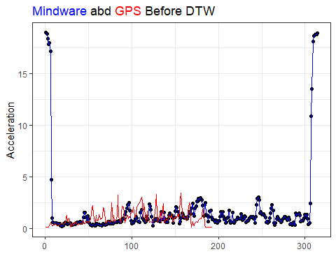

alignment<-dtw::dtw(G$Acceleration,M$Acceleration,  
 keep=TRUE,step=asymmetric,  
 open.end=TRUE,open.begin=TRUE)  
### Two acceleration signals After synchronization  
qplot(data=M[alignment$index2,],y=Acceleration)+geom_line(col="blue")+  
 geom_line(data=G[alignment$index1,],col="red")+  
 theme_bw()+  
 ggtitle("<span style = 'color: blue;'>Mindware</span> abd   
 <span style = 'color: red;'>GPS</span> After DTW")+  
 theme(plot.title = element_markdown())

